**Download Entities from IBM Knowledge Studio**

Step 1: Login and launch Watson Knowledge Studio, then click workspace.

Step 2: Click Assets > Entity Types.

Step 3: Click on Download type.

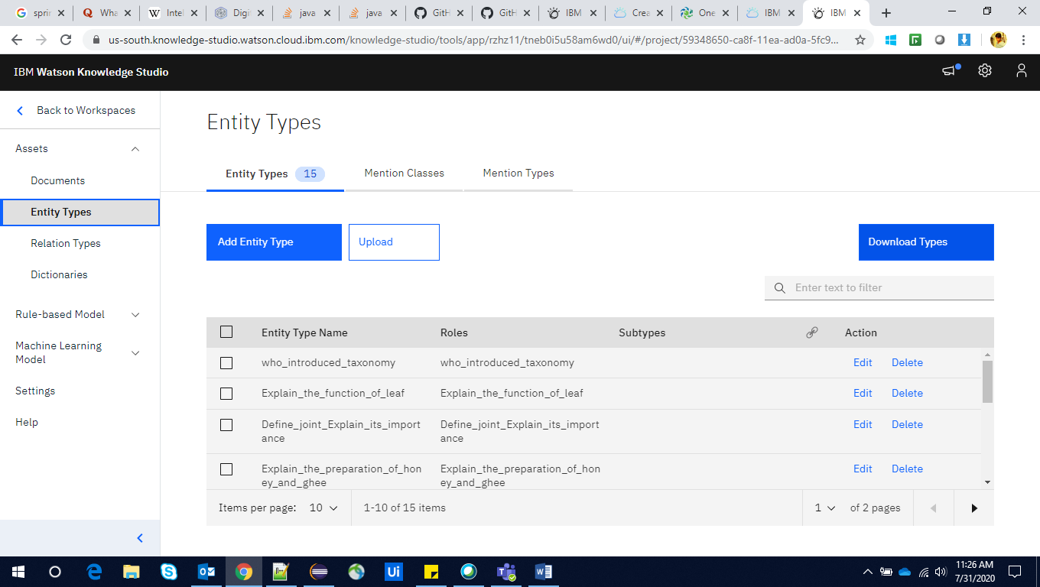

The Json document will be downloaded and integrate it to SOLR for further processes.